1940BW

IP65 19x40W Bee Eye Zoom

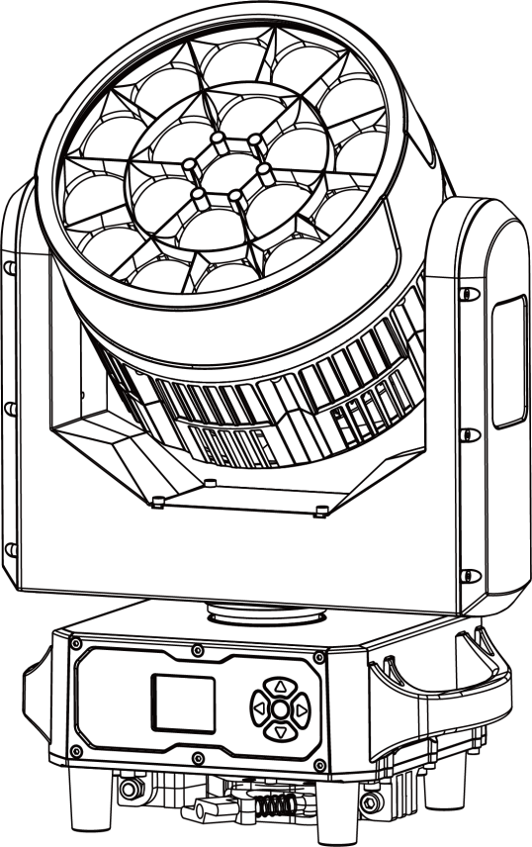

USER MANUAL
Please read manual carefully before use

CONTENTS
1. Safety Instructions 3
2. Technical Specification 5
3. DMX Set Up 6
4. Display 7
5. Menu 8
6. LUX Data 11
7. DMX Channel List 11
8. Mounting 11
9. Product Size 36
10. Attention 36
11. Trouble Shooting 37
A. The unit does not work, no light and the fan does not work 37
B. Not responding to DMX controller 37
C. One of the channels is not working well 37
12. Fixture Cleaning 38

Thank you for choosing our LED lights. Each facility has been rigorously tested. Please check whether the facility has been damaged during transportation. If you find any parts are missing or broken, please contact the manufacturer immediately. Please do not return the product without any notice!

1.Safety Instructions

Please read this manual carefully, which includes
important information on installation,use and maintenance.

Attention
- Please keep this USER MANUAL for future consultation. If you sell the facility to another user, be sure that they also receive this USER MANUAL.
- Please open and check in details and make sure there is no transportation damage.
- Before operating, ensure that the voltage and frequency of power supply match the power requirements of the facility.
- It’s important to ground the yellow/green conductor to earth in order to avoid electric shock.
- The facility must be installed in a location with adequate ventilation, at least 50 cm from adjacent surfaces. Be sure that no ventilation slots are blocked.
- Make sure the power is disconnected before removing the facility.
- Make sure there are no flammable materials close to the unit while operating as it is fire hazard.
- Use safety cable when fixes this facility. Do not handle the facility by taking its head only, but always by taking its base.
- Maximum ambient temperature is 40℃. Do not operate it where the temperature is higher than this.
- Please stop using the facility for serious operating problems. Stop using the facility immediately. Never try to repair the facility by yourself, but be a professional technician. Please contact the supplier’s service department for technical support.
- Do not touch any wire during operation as high voltage might be causing electric shock.
- When the housing or lens is damaged, it must be replaced.
- Direct sunlight or any other strong light source penetrating the lens of the light will cause serious internal damage to the facility. During unpacking, installation, use and long-term outdoor idleness, it is forbidden to expose the lens of the facility to direct sunlight or any other strong light source at any angle. It is forbidden to aim the beam of one light directly at another light.

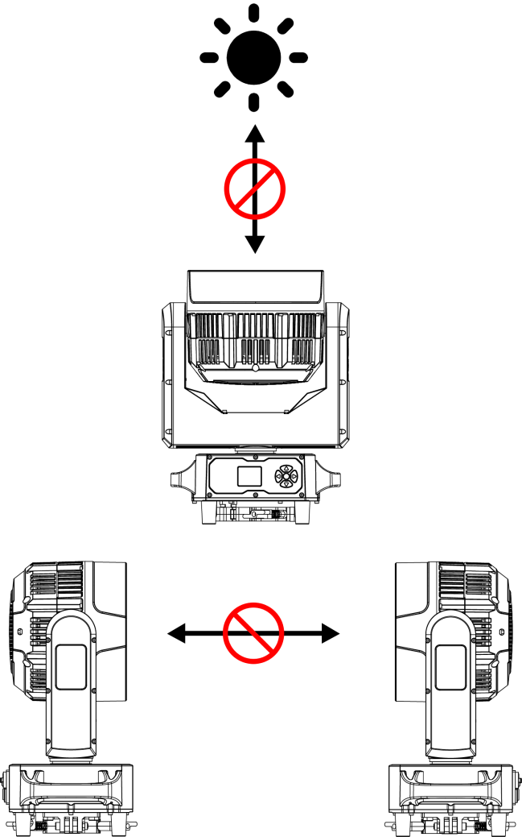
Caution
There are no accessories available, do not open the housing and try to repair the facilities yourself. Please contact our company for after service.

Installation

The unit should be mounted via its screw holes on the bracket. Always ensure that the unit is firmly fixed to avoid vibration and slipping while operating. And make sure that the structure to which you are attaching the unit is secure and is able to support a weight of 10 times of the unit’s weight. Also always use a safety cable that can hold 12 times of the weight of the unit when installing the fixture.

The facility must be installed by professionals, and keep it far away from fire, walking road, and easy touched place.

2. Technical Specification

Light Source | 19*40W 4 in 1 RGBW LED
LED Lifetime | ≥ 50000H
Power Voltage | AC100-240V ，50-60Hz
Power Consumption | 650W
Beam Angle | 3.5°-48°
Control Modes | DMX512、Auto、Sound、Master、Manual、RDM、ArtNet(Optional)
DMX Channel | 21/ 23/ 35/ 78/ 92/ 97/ 99/76(DMX+ArtNet) Channel
Protection Rating | IP65
Display | TFT 1.8inch Display
Data In/Out Socket | IP65 3-pin XLR sockets
Power Socket | IP65 Power-Con in/ out
Housing Material | Die casting + flame retardant black carbon fiber
Pan | 540°accuracy 2.11°/step, fine-tuning accuracy: 0.008°
Tilt | 270°accuracy 0.86°/step, fine-tuning accuracy: 0.0034°
Pan/Tilt Resolution | Automatically correct pan/tilt position
MAX. Connection | 5 units（240V，50Hz） 2.5mm² power cable
MAX. Connection | 3 units（100V，60Hz） 2.5mm² power cable
Dimension | 341*250*463mm
Net Weight | 14kg
Carton Package | 58*37*45cm 1in1 GW: 17kg
Flight Case | 83*74*67cm 4in1 GW: 96kg
Features | Full light range dimming, 65536-level dimming accuracy. fast strobe 1-25Hz.LED single control; three-in-one effects of WASH, Beam, and Bee Eye; Preset multiple color macro functions; preset multiple effect macro functions
Configuration | Signal cable 1pc
Configuration | Power cable 1pc
Configuration | Manual 1pc

3. DMX Set Up

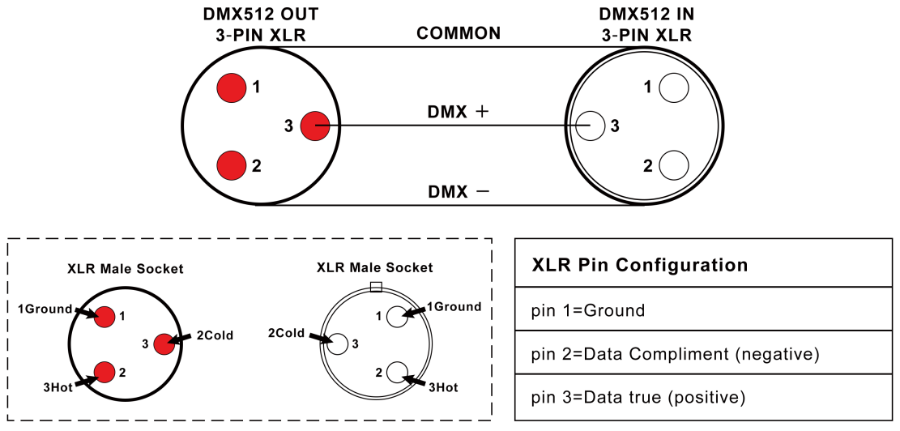

Pin1: Ground pin2: Negative pin3: Positive

DMX Connection

To ensure optimal transmission of DMX data, please connect facilities in the shortest way. The connection order won't affect the DMX address code. For example, if the address code is set to 1, no matter where the facility is connected, its address code will not change. This is determined by the principle of the DMX controller.
Operation method

You can operate in the following three modes:
- Auto mode - the light can automatically complete all color changes
- DMX control mode - each light can be individually controlled by a standard DMX512 console
- Master mode - any light can work as a host in any of the above modes, and the other lights will work synchronously as slaves

4. Display

There are Five buttons on the LED panel: MENU, UP, DOWN, and ENTER.

Display
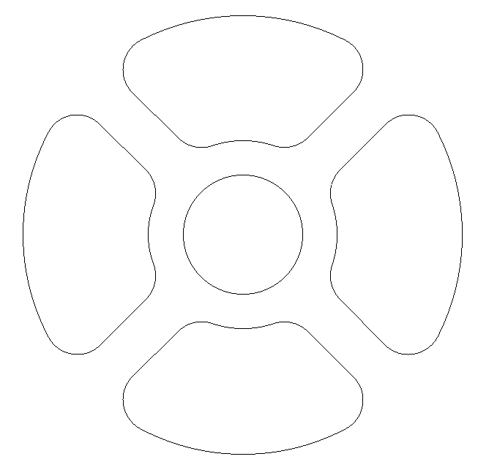
5
4
3
2
1

1 previous-MENU 2 UP 3 DOWN 4 Lower-MENU 5 ENTER

Please press the "MENU" to exit or return to the previous menu, press "UP" or "DOWN" to select the upper and lower menus or adjust the values, and press "ENTER" to confirm.

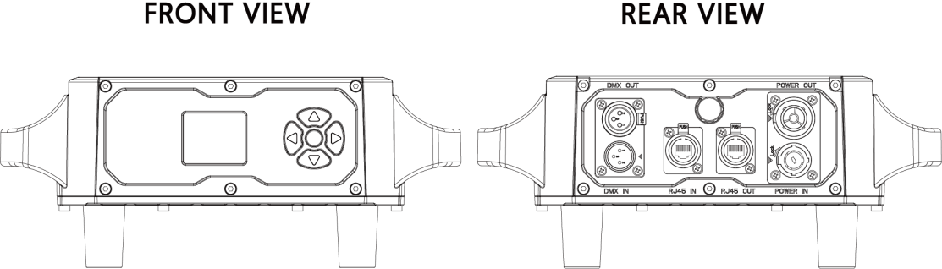

After powering on, the facility will automatically return to the last operation when it was powered off, then get into standby status. For more details, please refer to the information below↓

- Menu

1-MENU 2-UP 3-DOWN 4-ENTER
Menu | 1.Pan Degree | 1.540 2.360 | Pan running angle selection
Menu | 2.Mic Sense | 001--100 | Sound sensitivity
Menu | 3.Language | 1.English 2.Chinese | Select Display Language
Menu | 4.No Signal | 1.BlackOut 2.Hold
Menu | 5.Fan Set | 1.Auto 2.Low 3.High
Menu | 6.ArtNet Set | 1.ArtNet Enable: 1.ON 2.OFF | when ArtNet function is available
Menu | 6.ArtNet Set | 2.Universe:0---255 | when ArtNet function is available
Menu | 6.ArtNet Set | 3.IP Mode：A.2.X.X.X Auto B.10.X.X.X Auto C.Custom | when ArtNet function is available
Menu | 6.ArtNet Set | 4.Custom IP:192.168.000.001 | when ArtNet function is available
Menu | 6.ArtNet Set | 5.SubNetMask：255.000.000.000 | when ArtNet function is available
Menu | 7.Reset | 1.Yes | Reset
Menu | 7.Reset | 2.No | Reset
Menu | 8.Default | 1.Yes | Factory setting
Menu | 8.Default | 2.No | Factory setting
Menu | 9.Adjust | Pass Word：up+down+up+down | Change the value of Pan/Tilt/Focus/Rota to correct the angle; change the value of R/G/B/W to adjust the white balance.
Menu | 9.Adjust | 1.Pan: 0--255
Menu | 9.Adjust | 2.Tilt: 0--255
Menu | 9.Adjust | 3.Focus: 0--255
Menu | 9.Adjust | 4.Rota：0--255
Menu | 9.Adjust | 5.Red：0--255
Menu | 9.Adjust | 6.Greed：0--255
Menu | 9.Adjust | 7.Blue：0--255
Menu | 9.Adjust | 8.White：0--255
Addr | 001--512 |  | Setting the address from 001-512
Rever | 1.Pan Invert | 1.YES 2.NO | Pan Font Forward and Reverse Switching
Rever | 2.Tilt Invert | 1.YES 2.NO | Tilt Font Forward and Reverse Switching
Rever | 3.Display Invert | 1.YES 2.NO | Display Font Forward and Reverse Switching
Inform | 1.CH Value |  | Shown all channel information
Inform | 2.Tem**℃ |  | Show the temperature of LED board
Inform | 3.Version:** |  | Program version number
Inform | 4.IP:** ** ** ** |  | With ArtNet
Inform | 3.Kask:** ** ** **） |  | With ArtNet
Mode | 1.DMX512 |  | Setting control mode
Mode | 2.Auto |  | Setting control mode
Mode | 3.Sound |  | Setting control mode
Mode | 4.Manual | Master/Alone | Master/Alone
Mode | 4.Manual | 1.Pan: 0--255 | Manual control
Mode | 4.Manual | 2.Tilt: 0--255 | Manual control
Mode | 4.Manual | 3.Focus: 0--255 | Manual control
Mode | 4.Manual | 4.Rota: 0--255 | Manual control
Mode | 4.Manual | 5.Red1: 0--255 | Manual control
Mode | 4.Manual | 6.Greed1: 0--255 | Manual control
Mode | 4.Manual | 7.Blue1: 0--255 | Manual control
Mode | 4.Manual | 8.White1: 0--255 | Manual control
Mode | 4.Manual | 9.Strobe1: 0-255 | Manual control
Channel | 1.21CH | 1.21Channels | Select channel mode
Channel | 2.23CH | 2.23Channels | Select channel mode
Channel | 3.35CH | 3.35Channels | Select channel mode
Channel | 4.78CH | 4.78Channels | Select channel mode

6. LUX Data
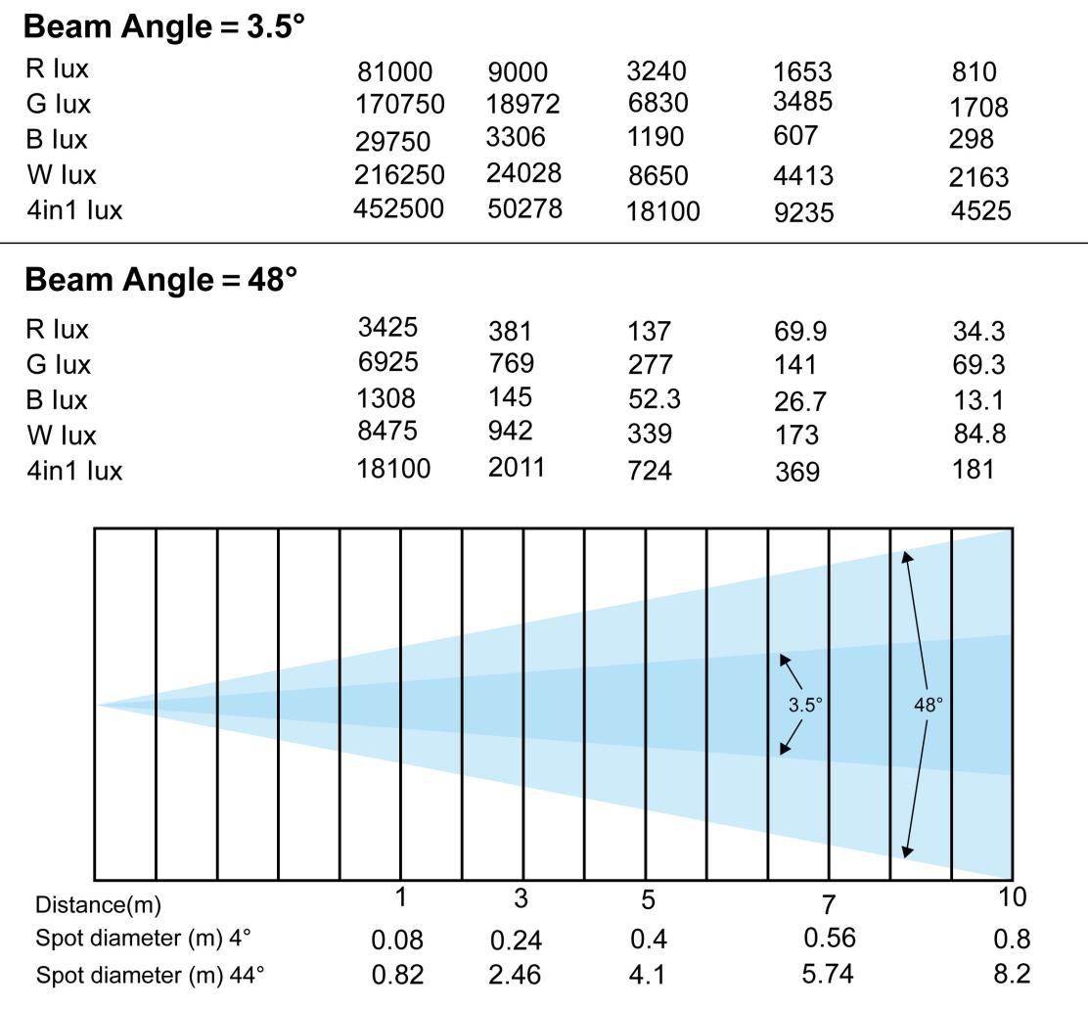

7. DMX Channel List
▶21CH Mode
CH | Function | DMX Value | Description
1 | Red | 0-255 | Red dimming
2 | Red adjustment | 0-255 | Red adjustment
3 | Green | 0-255 | Green dimming
4 | Green adjustment | 0-255 | Green adjustment
5 | Blue | 0-255 | Blue dimming
6 | Blue adjustment | 0-255 | Blue dimming
7 | White | 0-255 | White dimming
8 | White adjustment | 0-255 | White adjustment
9 | Color temperature | 0-15 | No function
9 | Color temperature | 16-35 | R100%, G UP, B0%
9 | Color temperature | 36-55 | R DOWN, G100%, B0%
9 | Color temperature | 56-75 | R0%, G100%, B UP
9 | Color temperature | 76-95 | R0%, G DOWN, B100%
9 | Color temperature | 96-115 | R UP, G0%, B100%
9 | Color temperature | 116-135 | R100%, G0%, B DOWN
9 | Color temperature | 136-155 | R100%, G UP, B UP
9 | Color temperature | 156-175 | R DOWN, G DOWN, B 100%
9 | Color temperature | 176-195 | R100%, G100%, B100%, W100%
9 | Color temperature | 196-200 | 2800K
9 | Color temperature | 201-205 | 3200K
9 | Color temperature | 206-210 | 3500K
9 | Color temperature | 211-215 | 4000K
9 | Color temperature | 216-220 | 4500K
9 | Color temperature | 221-225 | 5000K
9 | Color temperature | 226-230 | 5500K
9 | Color temperature | 231-235 | 6000K
9 | Color temperature | 236-240 | 6500K
9 | Color temperature | 241-245 | 7000K
9 | Color temperature | 246-250 | 7500K
9 | Color temperature | 251-255 | 8000K
10 | Macro color | 0-9 | No function
10 | Macro color | 10-19 | Macro color 1
10 | Macro color | 20-29 | Macro color 2
10 | Macro color | .... | .... (10 numbers 1 macro color)
10 | Macro color | 240-249 | Macro color 24
10 | Macro color | 250-255 | Macro color 25
11 | Strobe | 0-3 | Strobe dimming
11 | Strobe | 4-203 | Synchronous strobe speed from slow to fast (1Hz-25Hz)
11 | Strobe | 204-255 | Random strobe
12 | Dimmer | 0-255 | From dark to bright
13 | Dimmer adjust | 0-255 | Dimmer adjustment control
14 | Pan | 0-255 | Pan control
15 | Pan adjustment | 0-255 | Pan adjustment control
16 | Tilt | 0-255 | Tilt control
17 | Tilt adjustment | 0-255 | Tilt adjustment control
18 | Dimming Mode | 0-49 | Linear dimming
18 | Dimming Mode | 50-99 | Square rate dimming
18 | Dimming Mode | 100-149 | Inverse square rate dimming
18 | Dimming Mode | 150-255 | S-curve dimming
19 | Reset | 0-137 | No function
19 | Reset | 138-149 | PWM output frequency 1K-64K (Within 3 seconds) 1K, 2K, 4K, 6K, 8K, 10K, 16K, 20K, 24K, 32K, 48K, 64K
19 | Reset | 150-159 | Fast dimming
19 | Reset | 160-169 | Slow dimming (from fast to slow)
19 | Reset | 170-250 | No function
19 | Reset | 251-255 | Reset within 3s
20 | Zoom | 0-255 | From narrow to wide
21 | Lens rotation | 0-155 | 0~60°
21 | Lens rotation | 156-205 | Clockwise infinite rotation
21 | Lens rotation | 206-255 | Counterclockwise infinite rotation

▶23CH Mode
CH | Function | DMX Value | Description
1 | Pan | 0-255 | 0-540°
2 | Pan adjustment | 0-255 | 16 bit adjustment
3 | Tilt | 0-255 | 0-205°
4 | Tilt adjustment | 0-255 | 16 bit adjustment
5 | Pan/Tilt speed | 0-255 | Speed from fast to slow
6 | Zoom | 0-255 | From narrow to wide
7 | Lens rotation | 0-155 | 0~60°
7 | Lens rotation | 156-205 | Clockwise infinite rotation from fast to slow
7 | Lens rotation | 206-255 | Counterclockwise infinite rotation from slow to fast
8 | Dimmer | 0 - 255 | From dark to bright
9 | Strobe | 0-3 | Strobe dimming
9 | Strobe | 4-203 | Synchronous strobe speed from slow to fast (1Hz-25Hz)
9 | Strobe | 204-255 | Random strobe
10 | R dimming | 0-255 | From dark to bright
11 | G dimming | 0-255 | From dark to bright
12 | B dimming | 0-255 | From dark to bright
13 | W dimming | 0-255 | From dark to bright
14 | Color temperature | 0 -15 | No function
14 | Color temperature | 16-35 | R100%, G UP, B0%
14 | Color temperature | 36-55 | R DOWN, G100%, B0%
14 | Color temperature | 56-75 | R0%, G100%, B UP
14 | Color temperature | 76-95 | R0%, G DOWN, B100%
14 | Color temperature | 96-115 | R UP, G0%, B100%
14 | Color temperature | 116-135 | R100%, G0%, BDOWN
14 | Color temperature | 136-155 | R100%, G UP, B UP
14 | Color temperature | 156-175 | R DOWN, G DOWN, B100%
14 | Color temperature | 176-195 | R100%, G100%, B100%, W100%
14 | Color temperature | 196-200 | 2800K
14 | Color temperature | 201-205 | 3200K
14 | Color temperature | 206-210 | 3500K
14 | Color temperature | 211-215 | 4000K
14 | Color temperature | 216-220 | 4500K
14 | Color temperature | 221-225 | 5000K
14 | Color temperature | 226-230 | 5500K
14 | Color temperature | 231-235 | 6000K
14 | Color temperature | 236-240 | 6500K
14 | Color temperature | 241-245 | 7000K
14 | Color temperature | 246-250 | 7500K
14 | Color temperature | 251-255 | 8000K
15 | Macro color | 0-9 | No function
15 | Macro color | 10-19 | Macro color 1
15 | Macro color | 20-29 | Macro color 2
15 | Macro color | .... | ....(10 numbers 1 macro color)
15 | Macro color | 240-249 | Macro color 24
15 | Macro color | 250-255 | Macro color 25
16 | Static pattern | 0-9 | No function
16 | Static pattern | 10-12 | Monochrome pattern 1
16 | Static pattern | 13-15 | Monochrome pattern 2
16 | Static pattern | ..... | .........(3 numbers 1 pattern)
16 | Static pattern | 208-210 | Monochrome pattern 67
16 | Static pattern | 211-213 | Mixed color pattern 1
16 | Static pattern | 214-216 | Mixed color pattern 2
16 | Static pattern | .... | ....(3 numbers 1 pattern)
16 | Static pattern | 250-252 | Mixed color pattern 14
16 | Static pattern | 253-255 | Mixed color pattern 15
17 | Dynamic pattern | 0-9 | No function
17 | Dynamic pattern | 10-12 | Monochrome dynamic pattern 1
17 | Dynamic pattern | 13-15 | Monochrome dynamic pattern 2
17 | Dynamic pattern | ...... | ......(3 numbers 1 pattern)
17 | Dynamic pattern | 155-159 | Monochrome dynamic pattern 39
17 | Dynamic pattern | 127-129 | Monochrome dynamic pattern 40
17 | Dynamic pattern | 130-132 | Mixed color dynamic pattern 1
17 | Dynamic pattern | 133-185 | Mixed color dynamic pattern 2
17 | Dynamic pattern | ...... | ......(3 numbers 1 pattern)
17 | Dynamic pattern | 181-183 | Mixed color dynamic pattern 18
17 | Dynamic pattern | 184-186 | Mixed color dynamic pattern 19
17 | Dynamic pattern | 187-255 | Save
18 | Dynamic pattern speed(with 17CH) | 0-127 | Clockwise ,from fast to slow
18 | Dynamic pattern speed(with 17CH) | 128-255 | Counterclockwise, from slow to fast
19 | Background R | 0-255 | From dark to bright
20 | Background G | 0-255 | From dark to bright
21 | Background B | 0-255 | From dark to bright
22 | Background W | 0-255 | From dark to bright
23 | Reset | 0-137 | No function
23 | Reset | 138-149 | PWM output frequency 1K-64K (Within 3 seconds) 1K, 2K, 4K, 6K, 8K, 10K, 16K, 20K, 24K, 32K, 48K, 64K
23 | Reset | 150-159 | Fast dimming
23 | Reset | 160-169 | Slow dimming (from fast to slow)
23 | Reset | 170-250 | No function
23 | Reset | 251-255 | Reset within 3s

▶35CH Mode
CH | Function | DMX Value | Description
1 | Red | 0-255 | Red dimming
2 | Red adjustment | 0-255 | Red adjustment
3 | Green | 0-255 | Green dimming
4 | Green adjustment | 0-255 | Green adjustment
5 | Blue | 0-255 | Blue dimming
6 | Blue adjustment | 0-255 | Blue dimming
7 | White | 0-255 | White dimming
8 | White adjustment | 0-255 | White adjustment
9 | Color temperature | 0-15 | No function
9 | Color temperature | 16-35 | R100%, G UP, B0%
9 | Color temperature | 36-55 | R DOWN, G100%, B0%
9 | Color temperature | 56-75 | R0%, G100%, B UP
9 | Color temperature | 76-95 | R0%, G DOWN, B100%
9 | Color temperature | 96-115 | R UP, G0%, B100%
9 | Color temperature | 116-135 | R100%, G0%, B DOWN
9 | Color temperature | 136-155 | R100%, G UP, B UP
9 | Color temperature | 156-175 | R DOWN, G DOWN, B 100%
9 | Color temperature | 176-195 | R100%, G100%, B100%, W100%
9 | Color temperature | 196-200 | 2800K
9 | Color temperature | 201-205 | 3200K
9 | Color temperature | 206-210 | 3500K
9 | Color temperature | 211-215 | 4000K
9 | Color temperature | 216-220 | 4500K
9 | Color temperature | 221-225 | 5000K
9 | Color temperature | 226-230 | 5500K
9 | Color temperature | 231-235 | 6000K
9 | Color temperature | 236-240 | 6500K
9 | Color temperature | 241-245 | 7000K
9 | Color temperature | 246-250 | 7500K
9 | Color temperature | 251-255 | 8000K
10 | Macro color | 0-9 | No function
10 | Macro color | 10-19 | Macro color 1
10 | Macro color | 20-29 | Macro color 2
10 | Macro color | .... | ....(10 numbers 1 macro color)
10 | Macro color | 240-249 | Macro color 24
10 | Macro color | 250-255 | Macro color 25
11 | Strobe | 0-3 | Strobe dimming
11 | Strobe | 4-203 | Synchronous strobe speed from slow to fast (1Hz-25Hz)
11 | Strobe | 204-255 | Random strobe
12 | Dimmer | 0-255 | From dark to bright
13 | Dimmer adjust | 0-255 | Dimmer adjustment control
14 | Pan | 0-255 | Pan control
15 | Pan adjustment | 0-255 | Pan adjustment control
16 | Tilt | 0-255 | Tilt control
17 | Tilt adjustment | 0-255 | Tilt adjustment control
18 | Dimming Mode | 0-49 | Linear dimming
18 | Dimming Mode | 50-99 | Square rate dimming
18 | Dimming Mode | 100-149 | Inverse square rate dimming
18 | Dimming Mode | 150-255 | S-curve dimming
19 | Reset | 0-137 | No function
19 | Reset | 138-149 | PWM output frequency 1K-64K (Within 3 seconds) 1K, 2K, 4K, 6K, 8K, 10K, 16K, 20K, 24K, 32K, 48K, 64K
19 | Reset | 150-159 | Fast dimming
19 | Reset | 160-169 | Slow dimming (from fast to slow)
19 | Reset | 170-250 | No function
19 | Reset | 251-255 | Reset within 3s
20 | Zoom | 0-255 | From narrow to wide
21 | Lens rotation | 0-155 | 0~60°
21 | Lens rotation | 156-205 | Clockwise infinite rotation
21 | Lens rotation | 206-255 | Counterclockwise infinite rotation
22 | Pattern rotation | 0-9 | No function
22 | Pattern rotation | 10-12 | Monochrome dynamic pattern 1
22 | Pattern rotation | 13-15 | Monochrome dynamic pattern 2
22 | Pattern rotation | ...... | ......(3 numbers 1 pattern)
22 | Pattern rotation | 155-159 | Monochrome dynamic pattern 39
22 | Pattern rotation | 127-129 | Monochrome dynamic pattern 40
22 | Pattern rotation | 130-132 | Mixed color dynamic pattern 1
22 | Pattern rotation | 133-185 | Mixed color dynamic pattern 2
22 | Pattern rotation | ...... | ....(3 numbers 1 macro color)
22 | Pattern rotation | 181-183 | Mixed color dynamic pattern 18
22 | Pattern rotation | 184-186 | Mixed color dynamic pattern 19
22 | Pattern rotation | 187-255 | Save
23 | Pattern effect speed(with 22 CH） | 0-9 | No function
23 | Pattern effect speed(with 22 CH） | 10-132 | Clockwise ,from fast to slow
23 | Pattern effect speed(with 22 CH） | 133-255 | Counterclockwise, from slow to fast
24 | Pattern fade | 0-9 | No function
24 | Pattern fade | 10-132 | Slow Light to Slow Dark
24 | Pattern fade | 133-255 | Sudden Light to Slow Dark
25 | Pattern Background R | 0-255 | Pattern effect R
26 | Pattern Background G | 0-255 | Pattern effect G
27 | Pattern Background B | 0-255 | Pattern effect B
28 | Pattern Background W | 0-255 | Pattern effect W
29 | Pattern dimming | 0-255 | Pattern 0-100% dimming
30 | Background dimming | 0-255 | Background 0-100% dimming
31 | Pattern change | 0-255 | Pattern change control
32 | Pattern movement | 0-255 | Pattern movement(with 22 CH)
33 | Prospects strobe | 0-255 | Prospects strobe
34 | Background strobe | 0-255 | Background strobe
35 | Background pattern selection | 0-255 | Background selection

▶78CH Mode
CH | Function | DMX Value | Description
1 | Red | 0-255 | Red dimming
2 | Red adjustment | 0-255 | Red adjustment
3 | Green | 0-255 | Green dimming
4 | Green adjustment | 0-255 | Green adjustment
5 | Blue | 0-255 | Blue dimming
6 | Blue adjustment | 0-255 | Blue dimming
7 | White | 0-255 | White dimming
8 | White adjustment | 0-255 | White adjustment
9 | Color temperature | 0-15 | No function
9 | Color temperature | 16-35 | R100%,G UP,B0%
9 | Color temperature | 36-55 | R DOWN,G100%,B0%
9 | Color temperature | 56-75 | R0%,G100%,B UP
9 | Color temperature | 76-95 | R0%,G DOWN,B100%
9 | Color temperature | 96-115 | R UP,G0%,B100%
9 | Color temperature | 116-135 | R100%,G0%,B DOWN
9 | Color temperature | 136-155 | R100%,G UP,B UP
9 | Color temperature | 156-175 | R DOWN,G DOWN, B 100%
9 | Color temperature | 176-195 | R100%G100%B100%W100%
9 | Color temperature | 196-200 | 2800K
9 | Color temperature | 201-205 | 3200K
9 | Color temperature | 206-210 | 3500K
9 | Color temperature | 211-215 | 4000K
9 | Color temperature | 216-220 | 4500K
9 | Color temperature | 221-225 | 5000K
9 | Color temperature | 226-230 | 5500K
9 | Color temperature | 231-235 | 6000K
9 | Color temperature | 236-240 | 6500K
9 | Color temperature | 241-245 | 7000K
9 | Color temperature | 246-250 | 7500K
9 | Color temperature | 251-255 | 8000K
10 | Macro color | 0-9 | No function
10 | Macro color | 10-19 | Macro color 1
10 | Macro color | 20-29 | Macro color 2
10 | Macro color | .... | ....(10 numbers 1 macro color)
10 | Macro color | 240-249 | Macro color 24
10 | Macro color | 250-255 | Macro color 25
11 | Strobe | 0-3 | Strobe dimming
11 | Strobe | 4-203 | Synchronous strobe speed from slow to fast (1Hz-25Hz)
11 | Strobe | 204-255 | Random strobe
12 | Dimmer | 0-255 | From dark to bright
13 | Dimmer adjust | 0-255 | Dimmer adjustment control
14 | Pan | 0-255 | Pan control
15 | Pan adjustment | 0-255 | Pan adjustment control
16 | Tilt | 0-255 | Tilt control
17 | Tilt adjustment | 0-255 | Tilt adjustment control
18 | Dimming Mode | 0-49 | Linear dimming
18 | Dimming Mode | 50-99 | Square rate dimming
18 | Dimming Mode | 100-149 | Inverse square rate dimming
18 | Dimming Mode | 150-255 | S-curve dimming
19 | Reset | 0-137 | No function
19 | Reset | 138-149 | PWM output frequency 1K-64K (Within 3 seconds) 1K, 2K, 4K, 6K, 8K, 10K, 16K, 20K, 24K, 32K, 48K, 64K
19 | Reset | 150-159 | Fast dimming
19 | Reset | 160-169 | Slow dimming (from fast to slow)
19 | Reset | 170-250 | No function
19 | Reset | 251-255 | Reset within 3s
20 | Zoom | 0-255 | From narrow to wide
21 | Lens rotation | 0-155 | 0~60°
21 | Lens rotation | 156-205 | Clockwise infinite rotation
21 | Lens rotation | 206-255 | Counterclockwise infinite rotation
22 | R1 LED dimming | 0-255 | R1 LED dimming
23 | G1 LED dimming | 0-255 | G1 LED dimming
24 | B1 LED dimming | 0-255 | B1 LED dimming
25 | R2 LED dimming | 0-255 | R2 LED dimming
26 | G2 LED dimming | 0-255 | G2 LED dimming
27 | B2 LED dimming | 0-255 | B2 LED dimming
...... | ........... | .......... | ...........
76 | R19 LED dimming | 0-255 | R19 LED dimming
77 | G19 LED dimming | 0-255 | G19 LED dimming
78 | B19 LED dimming | 0-255 | B19 LED dimming

▶92CH Mode
CH | Function | DMX Value | Description
1 | Red | 0-255 | Red dimming
2 | Red adjustment | 0-255 | Red adjustment
3 | Green | 0-255 | Green dimming
4 | Green adjustment | 0-255 | Green adjustment
5 | Blue | 0-255 | Blue dimming
6 | Blue adjustment | 0-255 | Blue dimming
7 | White | 0-255 | White dimming
8 | White adjustment | 0-255 | White adjustment
9 | Color temperature | 0-15 | No function
9 | Color temperature | 16-35 | R100%,G UP,B0%
9 | Color temperature | 36-55 | R DOWN,G100%,B0%
9 | Color temperature | 56-75 | R0%,G100%,B UP
9 | Color temperature | 76-95 | R0%,G DOWN,B100%
9 | Color temperature | 96-115 | R UP,G0%,B100%
9 | Color temperature | 116-135 | R100%,G0%,B DOWN
9 | Color temperature | 136-155 | R100%,G UP,B UP
9 | Color temperature | 156-175 | R DOWN,G DOWN, B 100%
9 | Color temperature | 176-195 | R100%G100%B100%W100%
9 | Color temperature | 196-200 | 2800K
9 | Color temperature | 201-205 | 3200K
9 | Color temperature | 206-210 | 3500K
9 | Color temperature | 211-215 | 4000K
9 | Color temperature | 216-220 | 4500K
9 | Color temperature | 221-225 | 5000K
9 | Color temperature | 226-230 | 5500K
9 | Color temperature | 231-235 | 6000K
9 | Color temperature | 236-240 | 6500K
9 | Color temperature | 241-245 | 7000K
9 | Color temperature | 246-250 | 7500K
9 | Color temperature | 251-255 | 8000K
10 | Macro color | 0-9 | No function
10 | Macro color | 10-19 | Macro color 1
10 | Macro color | 20-29 | Macro color 2
10 | Macro color | .... | ....(10 numbers 1 macro color)
10 | Macro color | 240-249 | Macro color 24
10 | Macro color | 250-255 | Macro color 25
11 | Strobe | 0-3 | Strobe dimming
11 | Strobe | 4-203 | Synchronous strobe speed from slow to fast (1Hz-25Hz)
11 | Strobe | 204-255 | Random strobe
12 | Dimmer | 0-255 | From dark to bright
13 | Dimmer adjust | 0-255 | Dimmer adjustment control
14 | Pan | 0-255 | Pan control
15 | Pan adjustment | 0-255 | Pan adjustment control
16 | Tilt | 0-255 | Tilt control
17 | Tilt adjustment | 0-255 | Tilt adjustment control
18 | Dimming Mode | 0-49 | Linear dimming
18 | Dimming Mode | 50-99 | Square rate dimming
18 | Dimming Mode | 100-149 | Inverse square rate dimming
18 | Dimming Mode | 150-255 | S-curve dimming
19 | Reset | 0-137 | No function
19 | Reset | 138-149 | PWM output frequency 1K-64K (Within 3 seconds) 1K, 2K, 4K, 6K, 8K, 10K, 16K, 20K, 24K, 32K, 48K, 64K
19 | Reset | 150-159 | Fast dimming
19 | Reset | 160-169 | Slow dimming (from fast to slow)
19 | Reset | 170-250 | No function
19 | Reset | 251-255 | Reset within 3s
20 | Zoom | 0-255 | From narrow to wide
21 | Lens rotation | 0-155 | 0~60°
21 | Lens rotation | 156-205 | Clockwise infinite rotation
21 | Lens rotation | 206-255 | Counterclockwise infinite rotation
22 | Pattern rotation | 0-9 | No function
22 | Pattern rotation | 10-12 | Monochrome dynamic pattern 1
22 | Pattern rotation | 13-15 | Monochrome dynamic pattern 2
22 | Pattern rotation | ...... | ......(3 numbers 1 pattern)
22 | Pattern rotation | 155-159 | Monochrome dynamic pattern 39
22 | Pattern rotation | 127-129 | Monochrome dynamic pattern 40
22 | Pattern rotation | 130-132 | Mixed color dynamic pattern 1
22 | Pattern rotation | 133-185 | Mixed color dynamic pattern 2
22 | Pattern rotation | ...... | ....(3 numbers 1 macro color)
22 | Pattern rotation | 181-183 | Mixed color dynamic pattern 18
22 | Pattern rotation | 184-186 | Mixed color dynamic pattern 19
22 | Pattern rotation | 187-255 | Save
23 | Pattern effect speed（with 22CH） | 0-9 | No function
23 | Pattern effect speed（with 22CH） | 10-132 | Clockwise ,from fast to slow
23 | Pattern effect speed（with 22CH） | 133-255 | Counterclockwise, from slow to fast
24 | Pattern fade | 0-9 | No function
24 | Pattern fade | 10-132 | Slow Light to Slow Dark
24 | Pattern fade | 133-255 | Sudden Light to Slow Dark
25 | Pattern Background R | 0-255 | Pattern effect R
26 | Pattern Background G | 0-255 | Pattern effect G
27 | Pattern Background B | 0-255 | Pattern effect B
28 | Pattern Background W | 0-255 | Pattern effect W
29 | Pattern dimming | 0-255 | Pattern 0-100% dimming
30 | Background dimming | 0-255 | Background 0-100% dimming
31 | Pattern change | 0-255 | Pattern change control
32 | Pattern movement | 0-255 | Pattern movement(with 22CH)
33 | Prospects strobe | 0-255 | Prospects strobe
34 | Background strobe | 0-255 | Background strobe
35 | Background pattern selection | 0-255 | Background selection
36 | LED1 R dimming | 0-255 | LED1 R dimming
37 | LED1 G dimming | 0-255 | LED1 G dimming
38 | LED1 B dimming | 0-255 | LED1 B dimming
...... | ........... | .......... | ................
90 | LED 19 R dimming | 0-255 | LED 19 R dimming
91 | LED 19 G dimming | 0-255 | LED 19 G dimming
92 | LED 19 B dimming | 0-255 | LED 19 B dimming

▶97CH Mode
CH | Function | DMX Value | Description
1 | Red | 0-255 | Red dimming
2 | Red adjustment | 0-255 | Red adjustment
3 | Green | 0-255 | Green dimming
4 | Green adjustment | 0-255 | Green adjustment
5 | Blue | 0-255 | Blue dimming
6 | Blue adjustment | 0-255 | Blue dimming
7 | White | 0-255 | White dimming
8 | White adjustment | 0-255 | White adjustment
9 | Color temperature | 0-15 | No function
9 | Color temperature | 16-35 | R100%, G UP, B0%
9 | Color temperature | 36-55 | R DOWN, G100% ,B0%
9 | Color temperature | 56-75 | R0%, G100%, B UP
9 | Color temperature | 76-95 | R0%, G DOWN, B100%
9 | Color temperature | 96-115 | R UP, G0%, B100%
9 | Color temperature | 116-135 | R100%, G0%, B DOWN
9 | Color temperature | 136-155 | R100%, G UP, B UP
9 | Color temperature | 156-175 | R DOWN, G DOWN, B 100%
9 | Color temperature | 176-195 | R100%, G100%, B100%, W100%
9 | Color temperature | 196-200 | 2800K
9 | Color temperature | 201-205 | 3200K
9 | Color temperature | 206-210 | 3500K
9 | Color temperature | 211-215 | 4000K
9 | Color temperature | 216-220 | 4500K
9 | Color temperature | 221-225 | 5000K
9 | Color temperature | 226-230 | 5500K
9 | Color temperature | 231-235 | 6000K
9 | Color temperature | 236-240 | 6500K
9 | Color temperature | 241-245 | 7000K
9 | Color temperature | 246-250 | 7500K
9 | Color temperature | 251-255 | 8000K
10 | Macro color | 0-9 | No function
10 | Macro color | 10-19 | Macro color 1
10 | Macro color | 20-29 | Macro color 2
10 | Macro color | .... | ....(10 numbers 1 macro color)
10 | Macro color | 240-249 | Macro color 24
10 | Macro color | 250-255 | Macro color 25
11 | Strobe | 0-3 | Strobe dimming
11 | Strobe | 4-203 | Synchronous strobe speed from slow to fast (1Hz-25Hz)
11 | Strobe | 204-255 | Random strobe
12 | Dimmer | 0-255 | From dark to bright
13 | Dimmer adjust | 0-255 | Dimmer adjustment control
14 | Pan | 0-255 | Pan control
15 | Pan adjustment | 0-255 | Pan adjustment control
16 | Tilt | 0-255 | Tilt control
17 | Tilt adjustment | 0-255 | Tilt adjustment control
18 | Dimming Mode | 0-49 | Mode -1
18 | Dimming Mode | 50-99 | Mode -2
18 | Dimming Mode | 100-149 | Mode -3
18 | Dimming Mode | 150-255 | Mode -4
19 | Reset | 0-137 | No function
19 | Reset | 138-149 | PWM output frequency 1K-64K (Within 3 seconds) 1K, 2K, 4K, 6K, 8K, 10K, 16K, 20K, 24K, 32K, 48K, 64K
19 | Reset | 150-159 | Fast dimming
19 | Reset | 160-169 | Slow dimming (from fast to slow)
19 | Reset | 170-250 | No function
19 | Reset | 251-255 | Reset within 3s
20 | Zoom | 0-255 | From narrow to wide
21 | Lens rotation | 0-155 | 0~60°
21 | Lens rotation | 156-205 | Clockwise infinite rotation
21 | Lens rotation | 206-255 | Counterclockwise infinite rotation
22 | R1 LED dimming | 0-255 | R1 LED dimming
23 | G1 LED dimming | 0-255 | G1 LED dimming
24 | B1 LED dimming | 0-255 | B1 LED dimming
25 | W1 LED dimming | 0-255 | W1 LED dimming
...... | ........... | .......... | ................
94 | R19 LED dimming | 0-255 | R19 LED dimming
95 | G19LED dimming | 0-255 | G19 LED dimming
96 | B19LED dimming | 0-255 | B19 LED dimming
97 | W19LED dimming | 0-255 | W19 LED dimming

▶99CH Mode
CH | Function | DMX Value | Description
1 | Pan | 0-255 | 0-540°
2 | Pan adjustment | 0-255 | 16 bit adjustment
3 | Tilt | 0-255 | 0-205°
4 | Tilt adjustment | 0-255 | 16 bit adjustment
5 | Pan&Tilt speed | 0-255 | Speed from fast to slow
6 | Zoom | 0-255 | From narrow to wide
7 | Lens rotation | 0-155 | 0~60°
7 | Lens rotation | 156-205 | Clockwise infinite rotation from fast to slow
7 | Lens rotation | 206-255 | Counterclockwise rotation from slow to fast
8 | Dimmer | 0-255 | From dark to bright
9 | Strobe | 0-3 | Strobe dimming
9 | Strobe | 4-203 | Synchronous strobe speed from slow to fast (1Hz-25Hz)
9 | Strobe | 204-255 | Random strobe
10 | R dimming | 0-255 | From dark to bright
11 | G dimming | 0-255 | From dark to bright
12 | B dimming | 0-255 | From dark to bright
13 | W dimming | 0-255 | From dark to bright
14 | Color temperature | 0-15 | No function
14 | Color temperature | 16-35 | R100%, G UP, B0%
14 | Color temperature | 36-55 | R DOWN, G100%, B0%
14 | Color temperature | 56-75 | R0%, G100%, B UP
14 | Color temperature | 76-95 | R0%, G DOWN, B100%
14 | Color temperature | 96-115 | R UP, G0%, B100%
14 | Color temperature | 116-135 | R100%, G0%, B DOWN
14 | Color temperature | 136-155 | R100%, G UP, B UP
14 | Color temperature | 156-175 | R DOWN, G DOWN, B100%
14 | Color temperature | 176-195 | R100%, G100%, B100%, W100%
14 | Color temperature | 196-200 | 2800K
14 | Color temperature | 201-205 | 3200K
14 | Color temperature | 206-210 | 3500K
14 | Color temperature | 211-215 | 4000K
14 | Color temperature | 216-220 | 4500K
14 | Color temperature | 221-225 | 5000K
14 | Color temperature | 226-230 | 5500K
14 | Color temperature | 231-235 | 6000K
14 | Color temperature | 236-240 | 6500K
14 | Color temperature | 241-245 | 7000K
14 | Color temperature | 246-250 | 7500K
14 | Color temperature | 251-255 | 8000K
15 | Macro color | 0-9 | No function
15 | Macro color | 10-19 | Macro color 1
15 | Macro color | 20-29 | Macro color 2
15 | Macro color | .... | ....(10 numbers 1 macro color)
15 | Macro color | 240-249 | Macro color 24
15 | Macro color | 250-255 | Macro color 25
16 | Static pattern | 0-9 | No function
16 | Static pattern | 10-12 | Monochrome pattern 1
16 | Static pattern | 13-15 | Monochrome pattern 2
16 | Static pattern | ..... | .........(3 numbers 1 pattern)
16 | Static pattern | 208-210 | Monochrome pattern 67
16 | Static pattern | 211-213 | Mixed color pattern 1
16 | Static pattern | 214-216 | Mixed color pattern 2
16 | Static pattern | .... | ....(3 numbers 1 pattern)
16 | Static pattern | 250-252 | Mixed color pattern 14
16 | Static pattern | 253-255 | Mixed color pattern 15
17 | Dynamic pattern | 0-9 | No function
17 | Dynamic pattern | 10-12 | Monochrome dynamic pattern 1
17 | Dynamic pattern | 13-15 | Monochrome dynamic pattern 2
17 | Dynamic pattern | ...... | ......(3 numbers 1 pattern)
17 | Dynamic pattern | 155-159 | Monochrome dynamic pattern 39
17 | Dynamic pattern | 127-129 | Monochrome dynamic pattern 40
17 | Dynamic pattern | 130-132 | Mixed color dynamic pattern 1
17 | Dynamic pattern | 133-185 | Mixed color dynamic pattern 2
17 | Dynamic pattern | ......（3 numbers 1 pattern） | ......(3 numbers 1 pattern)
17 | Dynamic pattern | 181-183 | Mixed color dynamic pattern 18
17 | Dynamic pattern | 184-186 | Mixed color dynamic pattern 19
17 | Dynamic pattern | 187-255 | Save
18 | Dynamic pattern speed（with 17CH） | 0-127 | Clockwise ,from fast to slow
18 | Dynamic pattern speed（with 17CH） | 128-255 | Counterclockwise, from slow to fast
19 | Background R | 0-255 | From dark to bright
20 | Background G | 0-255 | From dark to bright
21 | Background B | 0-255 | From dark to bright
22 | Background W | 0-255 | From dark to bright
23 | Reset | 0-137 | No function
23 | Reset | 138-149 | PWM output frequency 1K-64K (Within 3 seconds) 1K, 2K, 4K, 6K, 8K, 10K, 16K, 20K, 24K, 32K, 48K, 64K
23 | Reset | 150-159 | Fast dimming
23 | Reset | 160-169 | Slow dimming (from fast to slow)
23 | Reset | 170-250 | No function
23 | Reset | 251-255 | Reset within 3s
24 | R1 LED dimmer | 0-255 | R1 LED dimming
25 | G1LED dimmer | 0-255 | G1 LED dimming
26 | B1 LED dimmer | 0-255 | B1 LED dimming
27 | W1LED dimmer | 0-255 | W1 LED dimming
..... | …… | …… | ……
96 | R19 LED dimmer | 0-255 | R19 LED dimming
97 | G19 LED dimmer | 0-255 | G19 LED dimming
98 | B19 LED dimmer | 0-255 | B19 LED dimming
99 | W19 LED dimmer | 0-255 | W19 LED dimming

▶76CH Mode(DMX512 + ArtNet Mode)
CH | Function | DMX Value | Description
DMX512 signal control
1 | Pan | 0-255 | 0-540°
2 | Pan adjustment | 0-255 | 16 bit adjustment
3 | Tilt | 0-255 | 0-205°
4 | Tilt adjustment | 0-255 | 16 bit adjustment
5 | Pan/Tilt speed | 0-255 | Speed from fast to slow
6 | Zoom | 0-255 | From narrow to wide
7 | Lens rotation | 0-155 | 0~60°
7 | Lens rotation | 156-205 | Clockwise infinite rotation from fast to slow
7 | Lens rotation | 206-255 | Counterclockwise infinite rotation from slow to fast
8 | Dimmer | 0 - 255 | From dark to bright
9 | Dimming Mode | 0-49 | Linear dimming
9 | Dimming Mode | 50-99 | Square rate dimming
9 | Dimming Mode | 100-149 | Inverse square rate dimming
9 | Dimming Mode | 150-255 | S-curve dimming
10 | Reset | 0-137 | No function
10 | Reset | 138-149 | PWM output frequency 1K-64K (Within 3 seconds) 1K, 2K, 4K, 6K, 8K, 10K, 16K, 20K, 24K, 32K, 48K, 64K
10 | Reset | 150-159 | Fast dimming
10 | Reset | 160-169 | Slow dimming (from fast to slow)
10 | Reset | 170-250 | No function
10 | Reset | 251-255 | Reset within 3s
11 | Strobe | 0-3 | Strobe dimming
11 | Strobe | 4-203 | Synchronous strobe speed from slow to fast (1Hz-25Hz)
11 | Strobe | 204-255 | Random strobe
ArtNet signal control
1 | R1 LED dimmer | 0-255 | R1 LED dimming
2 | G1LED dimmer | 0-255 | G1 LED dimming
3 | B1 LED dimmer | 0-255 | B1 LED dimming
4 | W1LED dimmer | 0-255 | W1 LED dimming
…… | …… | …… | ……
73 | R19 LED dimmer | 0-255 | R19 LED dimming
74 | G19 LED dimmer | 0-255 | G19 LED dimming
75 | B19 LED dimmer | 0-255 | B19 LED dimming
76 | W19 LED dimmer | 0-255 | W19 LED dimming

- Mounting

When installing the unit, the trussing or area of installation must be able to hold 10 times the weight without any deformation. When installing the unit must be secured with a secondary safety attachment, e.g. an appropriate safety cable. Never stand directly under the facility while mounting, uninstalling or repairing facilities.

High-altitude mounting requires for extensive experience, including working load limits calculating , installation material, and periodic safety check of installation materials and facilities. If you’re lack of mentioned qualifications, do not attempt the installation yourself. These installation should be checked by a skilled person annually.
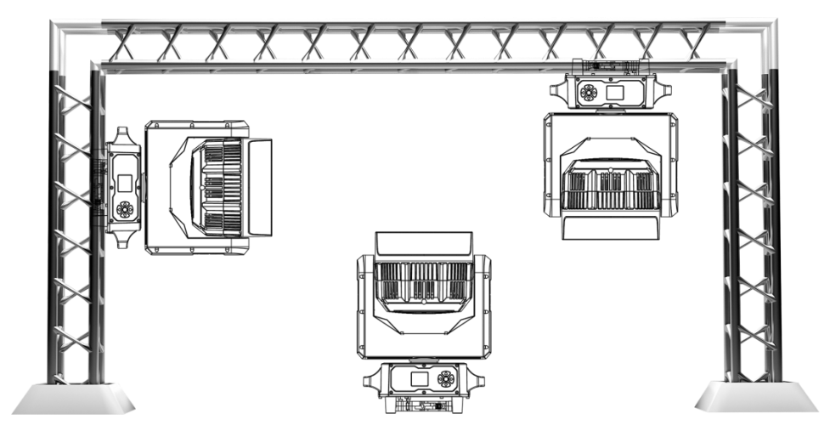
1940BW works properly in above different mounting, hanging upside-down from a ceiling, sideways on trussing, or set on smooth horizontal surface. Be sure this facility is at least 1m (3.5ft) away from flammable materials (decoration etc.). Always use and install the safety cable to prevent accidental damage or injury from the facility failure. Never use handles for secondary attachment.

NOTICE: The suitable environment temperature of the facility is from -10℃ to 45℃. Do not place this facility in an environment where the temperatures are under or above the temperatures stated. This will help the fixture run at its best and extend the lifetime.

- Product Size

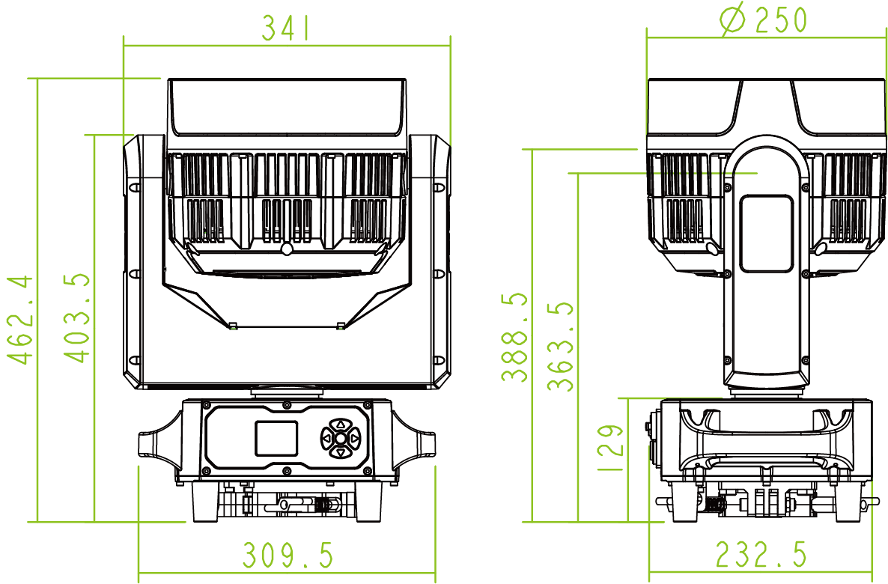

- Attention

1. When the facility is powered on, please avoid looking directly at the facility.

2. When assembling/ replacing LEDs, be sure to cut off the main power of facilities before opening the cover upon the LED board.

11. Trouble Shooting

Following are a few common problems that may occur during operation. Here are some suggestions for easy troubleshooting:

A. The unit does not work, no light and the fan does not work
1. Check the status of power connection and fuse.
2. Check the voltage.
3. Check the power indicator.

B. No response to DMX controller
1. If the display screen flashes, check the DMX signal connector and signal line whether the connection is correct.
2. If the display screen does not flash, but no response to channel control, check whether the address code or channel setting is correct.
3. If the DMX signal transmission is intermittent, check if the XLR and DMX cables are in good condition.
4. Try using another controller.
5. Check if the DMX cables is too close to the high-voltage wire, which may damage or interfere with the signal circuit.
6. The facility has not completed the self-check.

C. One of the channels is not working well
- The stepper motor might be damaged or the cable connected to the PCB is broken.
- The motor’s drive IC on the PCB might be out of condition.

12. Fixture Cleaning

The lens and diffuser should be clean frequently to get better light effect. Wipe frequency according to the environment. Humidity, excessive smoke, and dirty environment will make lens dusty.
● Use soft cloth and special glass cleaner.
● Wipe lens surface at least every 30 days.
● Use vacuum cleaners or air guns to clean the interior structure of the facility, at least twice a year.

Warning:
To avoid the danger of lighting strikes and fire, please do not place the facility in a humid environment. Do not disassemble it without permission, otherwise, the manufacturer will not provide warranty. If the facility fails, please contact the manufacturer first.

Product Warranty Card
Product: IP65 19×40W MINI Bee Eye Zoom
Model NO.: 1940BW Manufacture Date:
User: Purchase Date:
Manufacturer: Sales Store:
Address: ATTN.:
ATTN.: Phone:
Phone:
Note: The above blank must be filled in and sealed by the end user or sales point, otherwise no warranty will be provided. (Below please check the warranty period and terms)
Warranty Period: This facility is warranted for 2 years from the date of purchase.
Warranty Terms:
1. Except for man-made damage and natural disasters
2. If the facility fails to function properly during the warranty period, please contact our after service department or our local distributor directly.
1) Fail to present a valid warranty card.
2) Omissions, alterations, and trade sales names on the warranty card.
3) Failures and damage caused by force majeure.
4) Failures and damage caused during transportation and handling.
5) Failures and damage caused by failure to follow the instructions for use.
6) Failures and damage caused by disassembly, repair, and modification of the product without the manufacturer's authorization or by non-professionals.
7) Failures caused by the use of accessories not approved by the factory or not matched by the factory.

▲ Thank you for reading this manual. Please keep it for future reference.

